Name: Pujan Chaulagain

Contact:pujanchaulagain@gmail.com

Screenshots for dashboard:

1. AWS Login screen with username

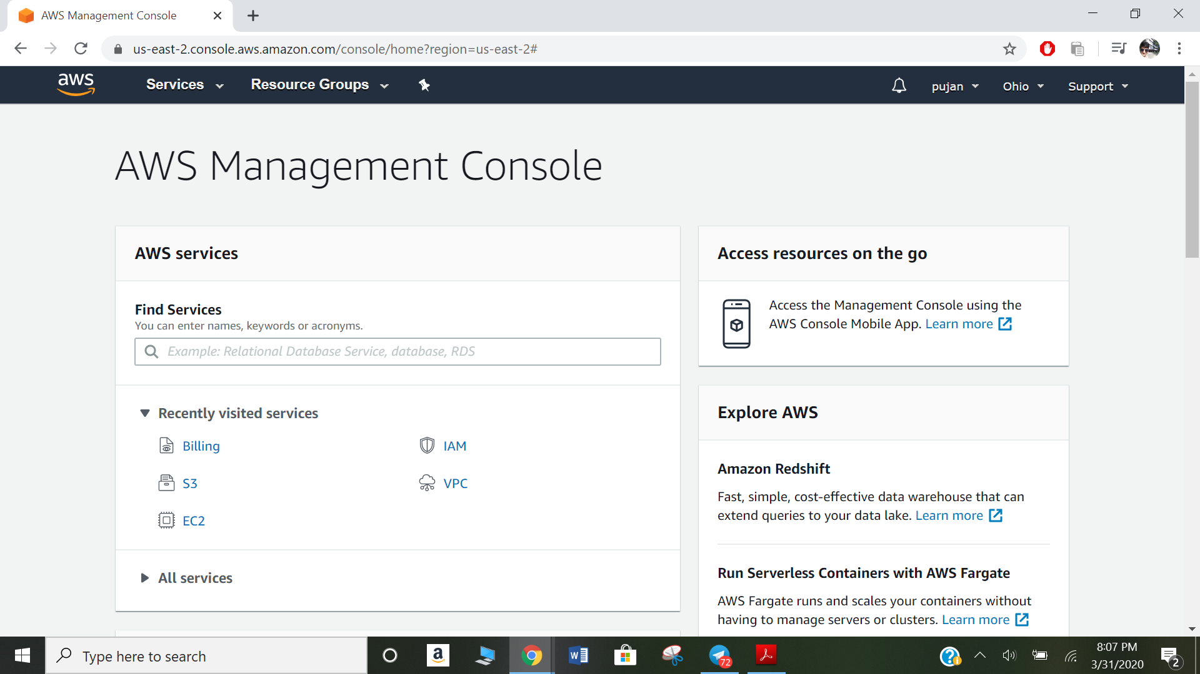

1. EC2 Dashboard

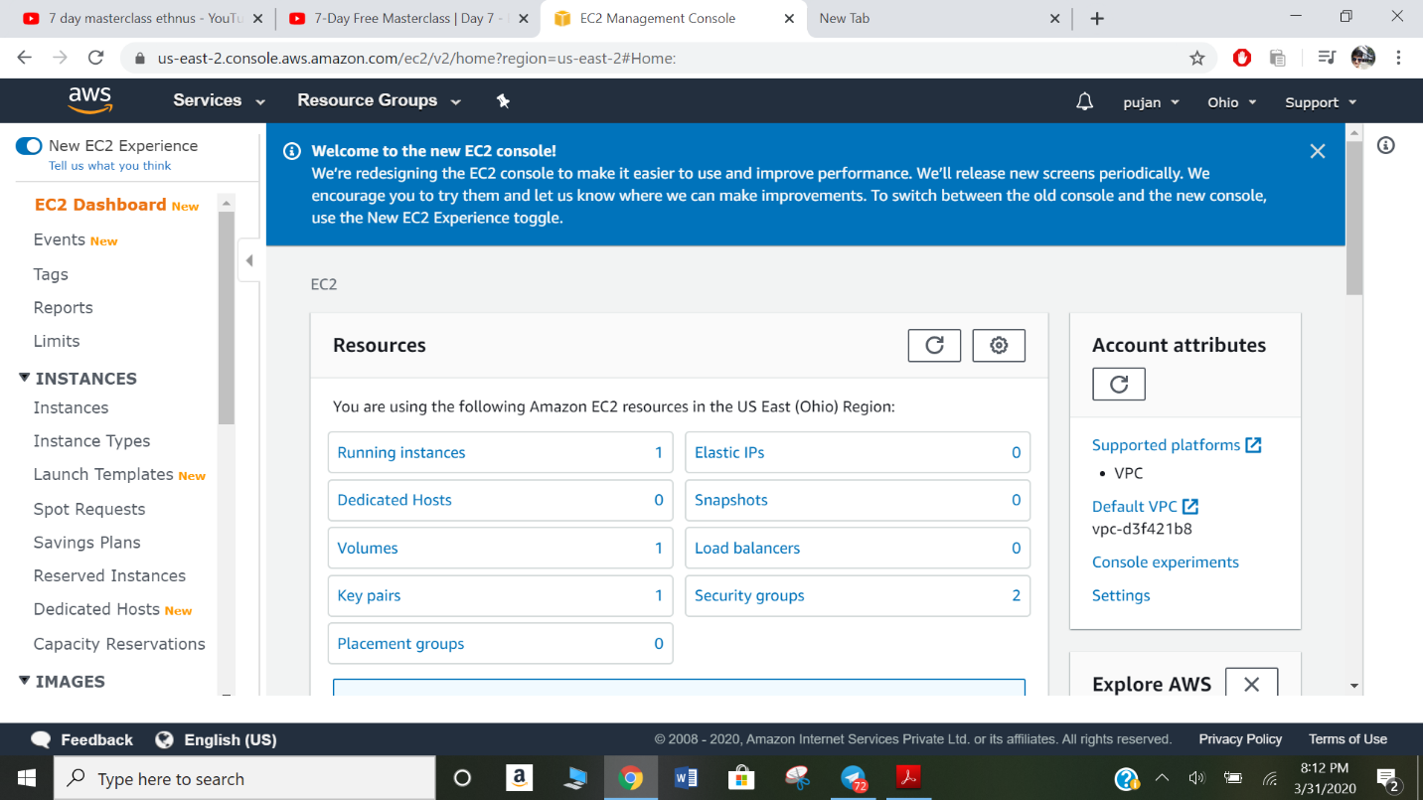

1. S3 Dashboard

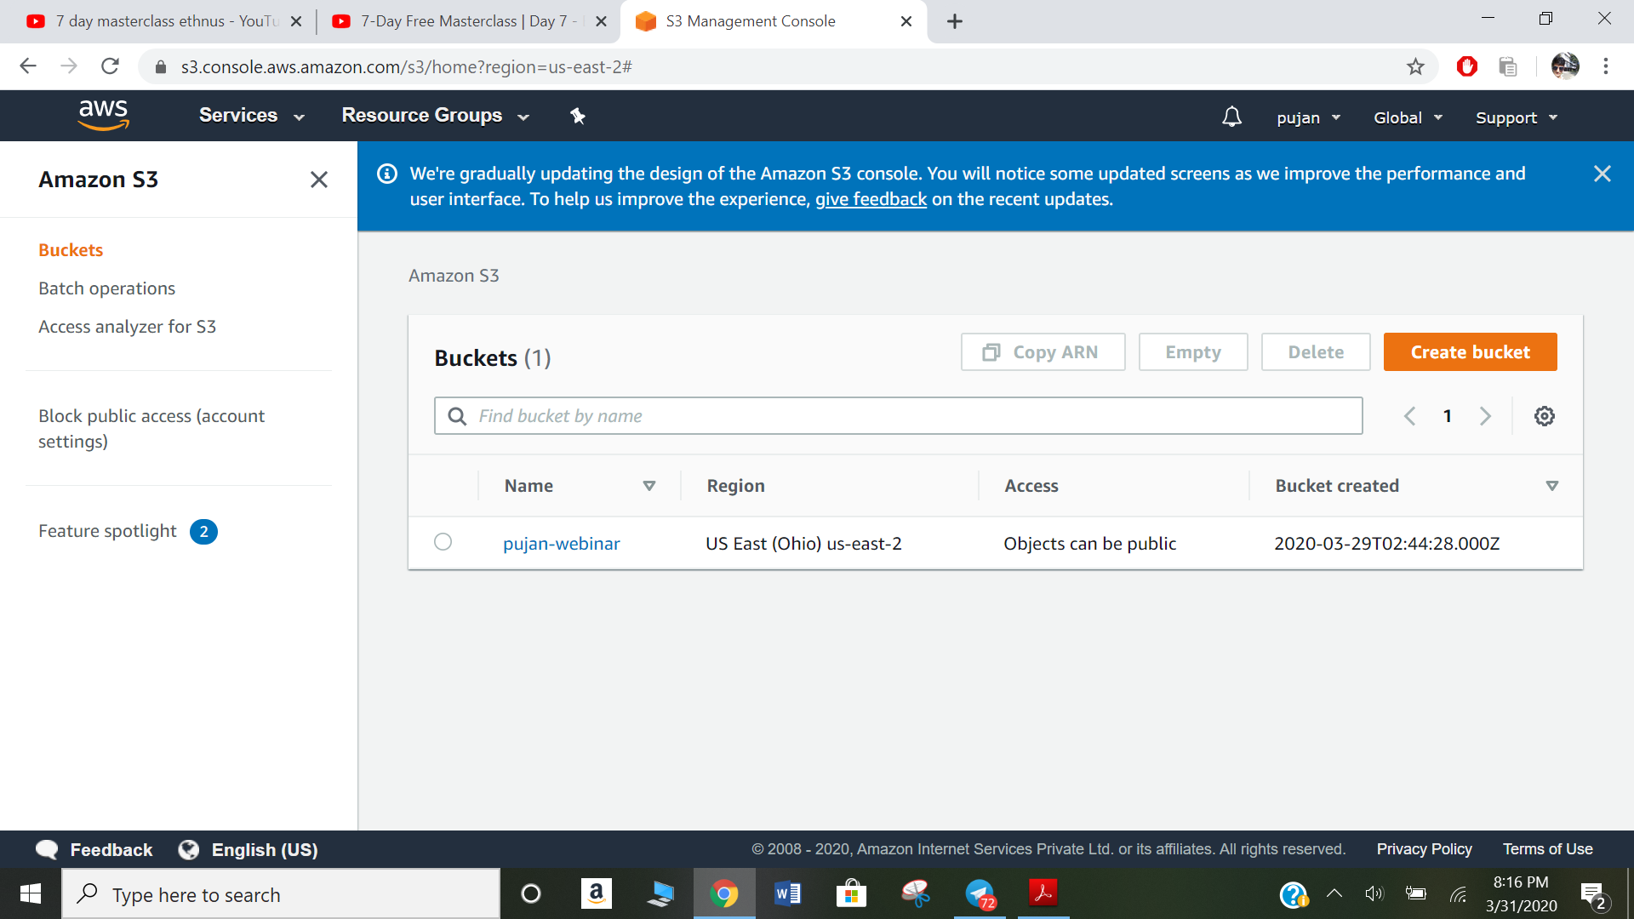

1. Rekognition Dashboard

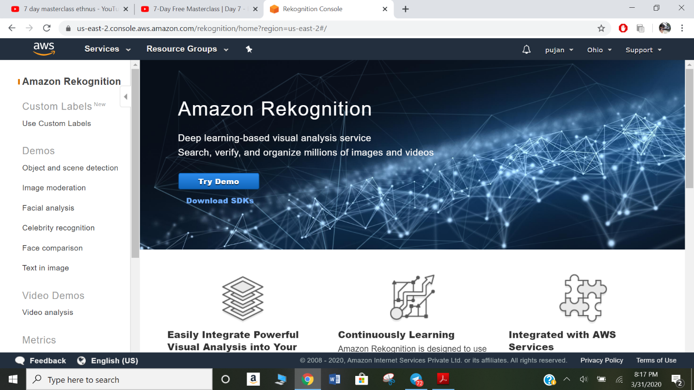

Screenshots needed for EC2

1. Choosing an AMI

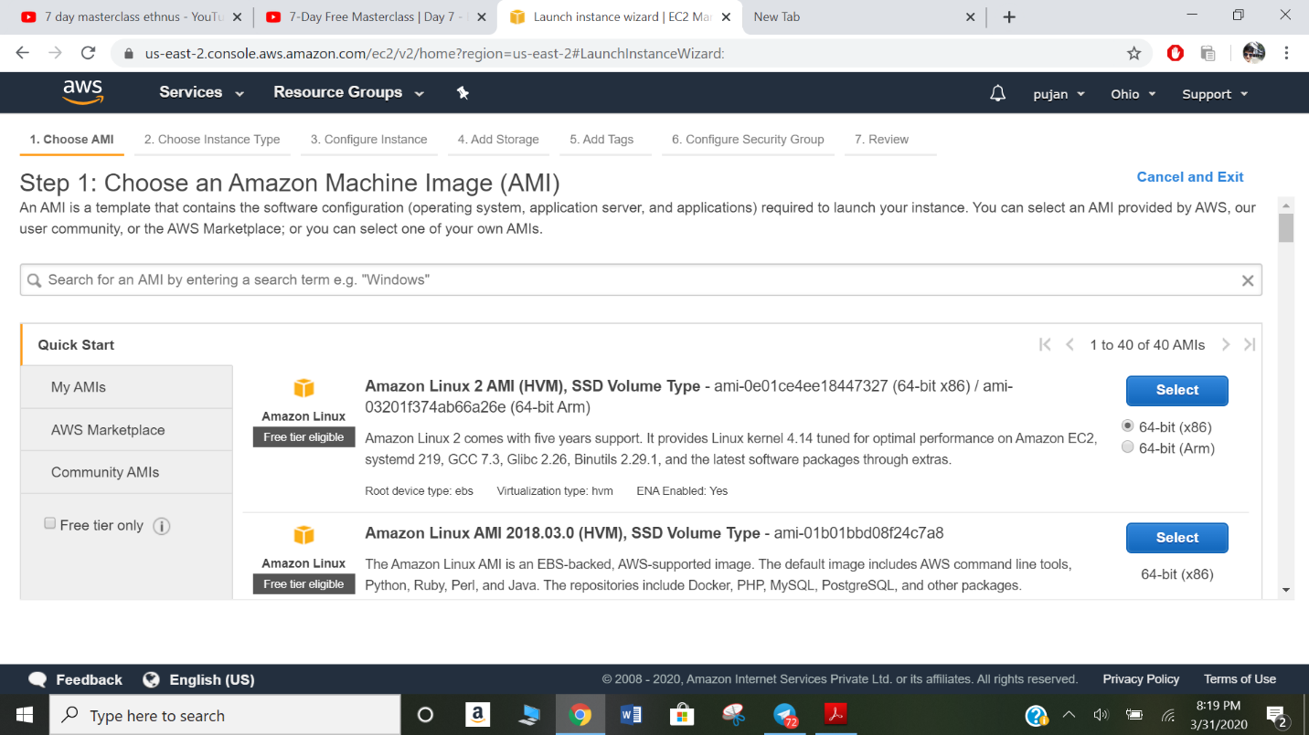

1. Choosing an Instance Type

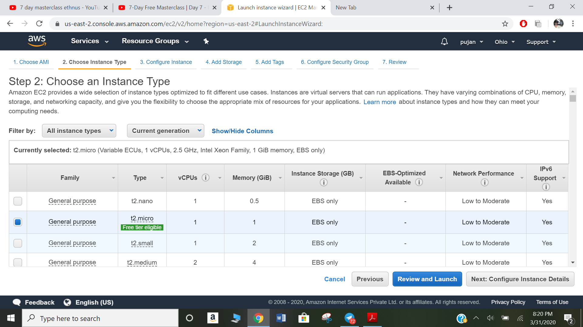

1. Adding Storage

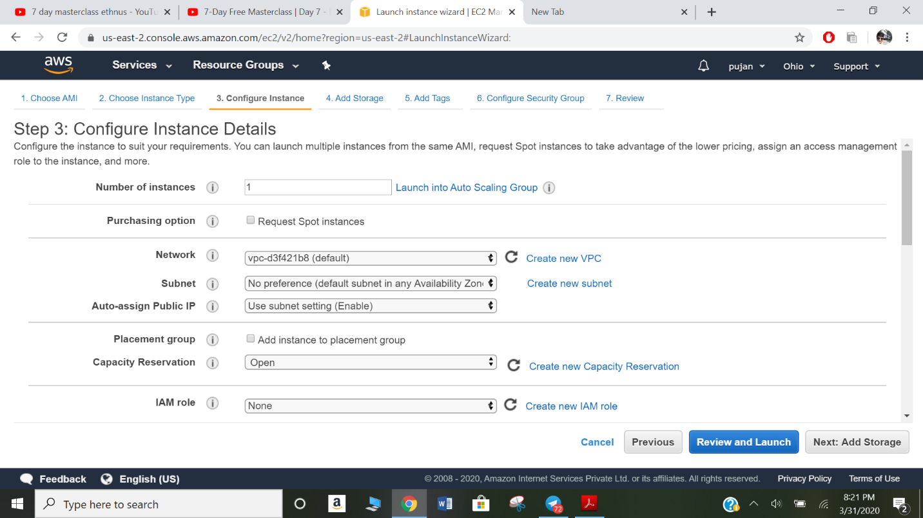

1. Configuring Security Group

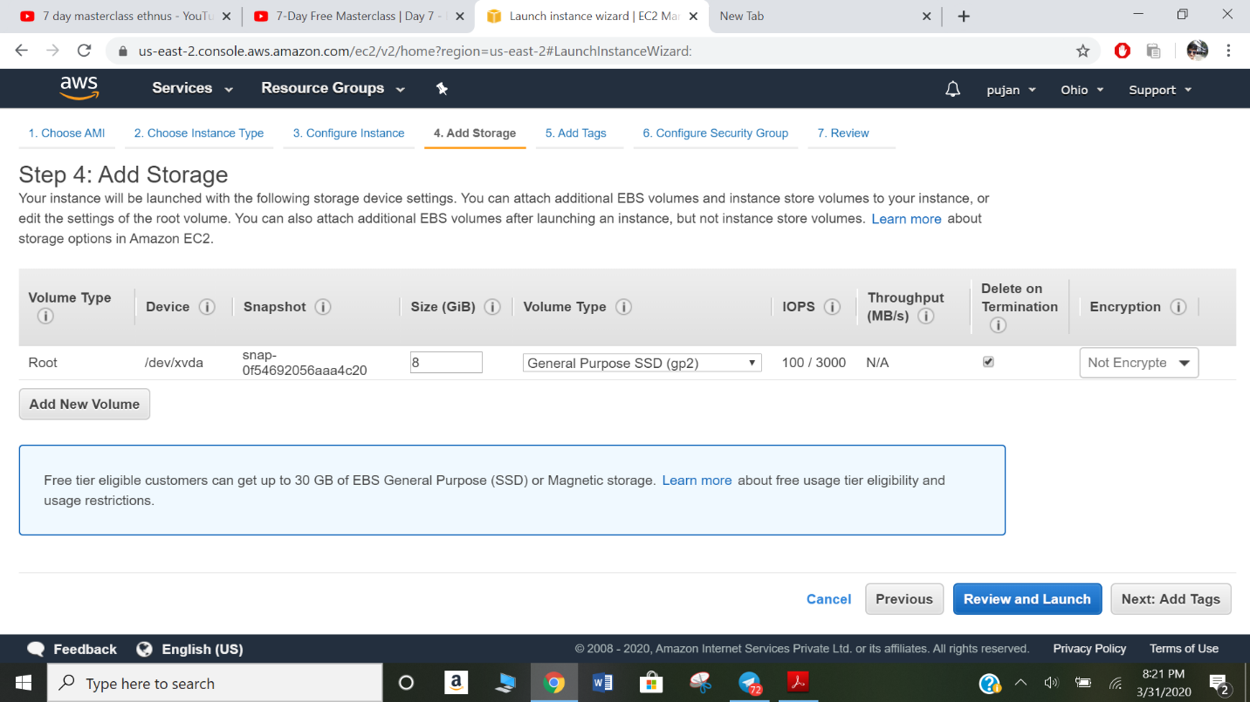

1. Key Pair Download

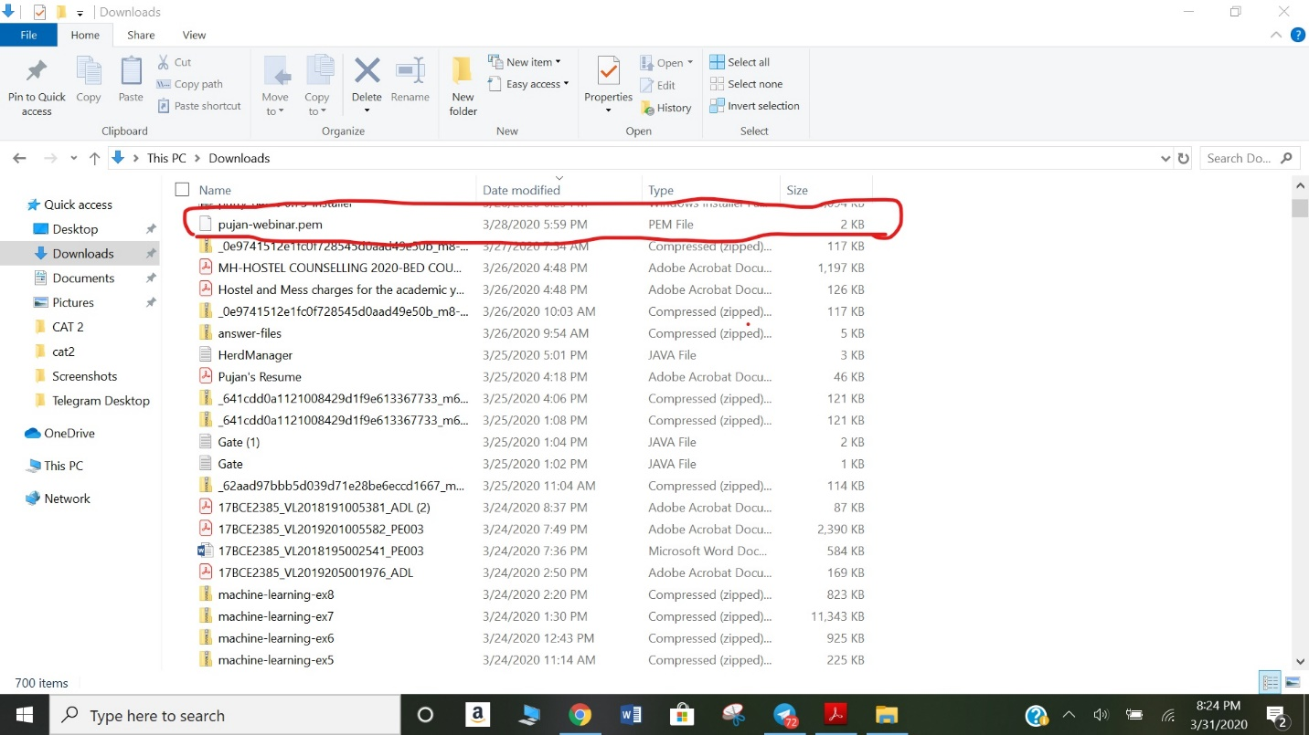

1. PuTTYgen conversion from pem to ppk

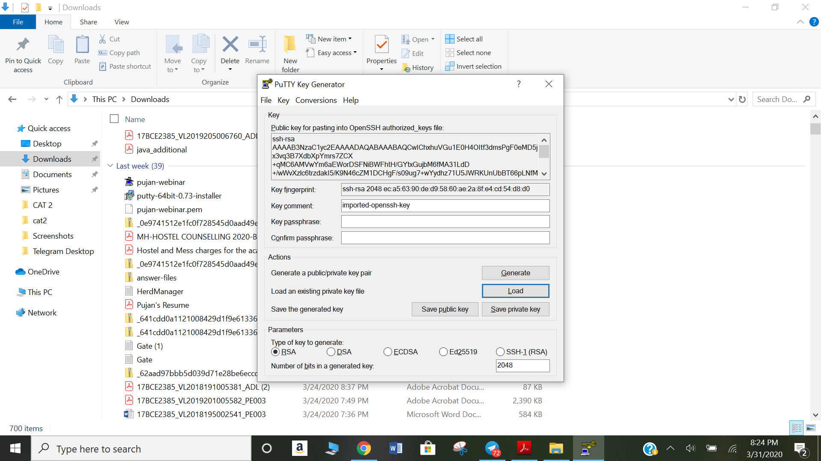

1. Logged in EC2 black screen

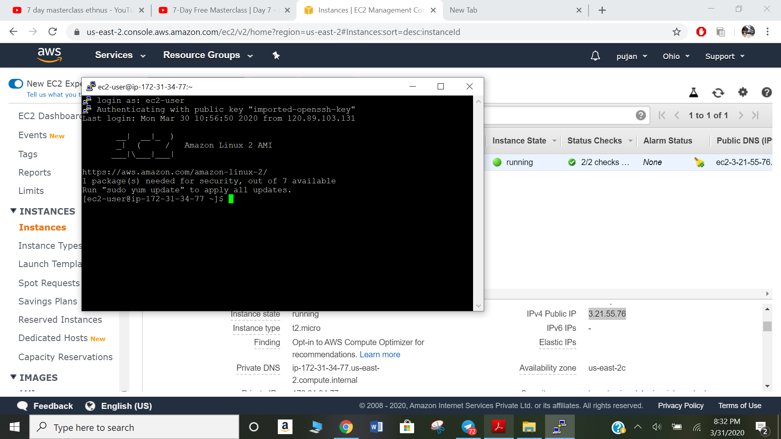

Screenshots needed for S3

1. Creating a bucket

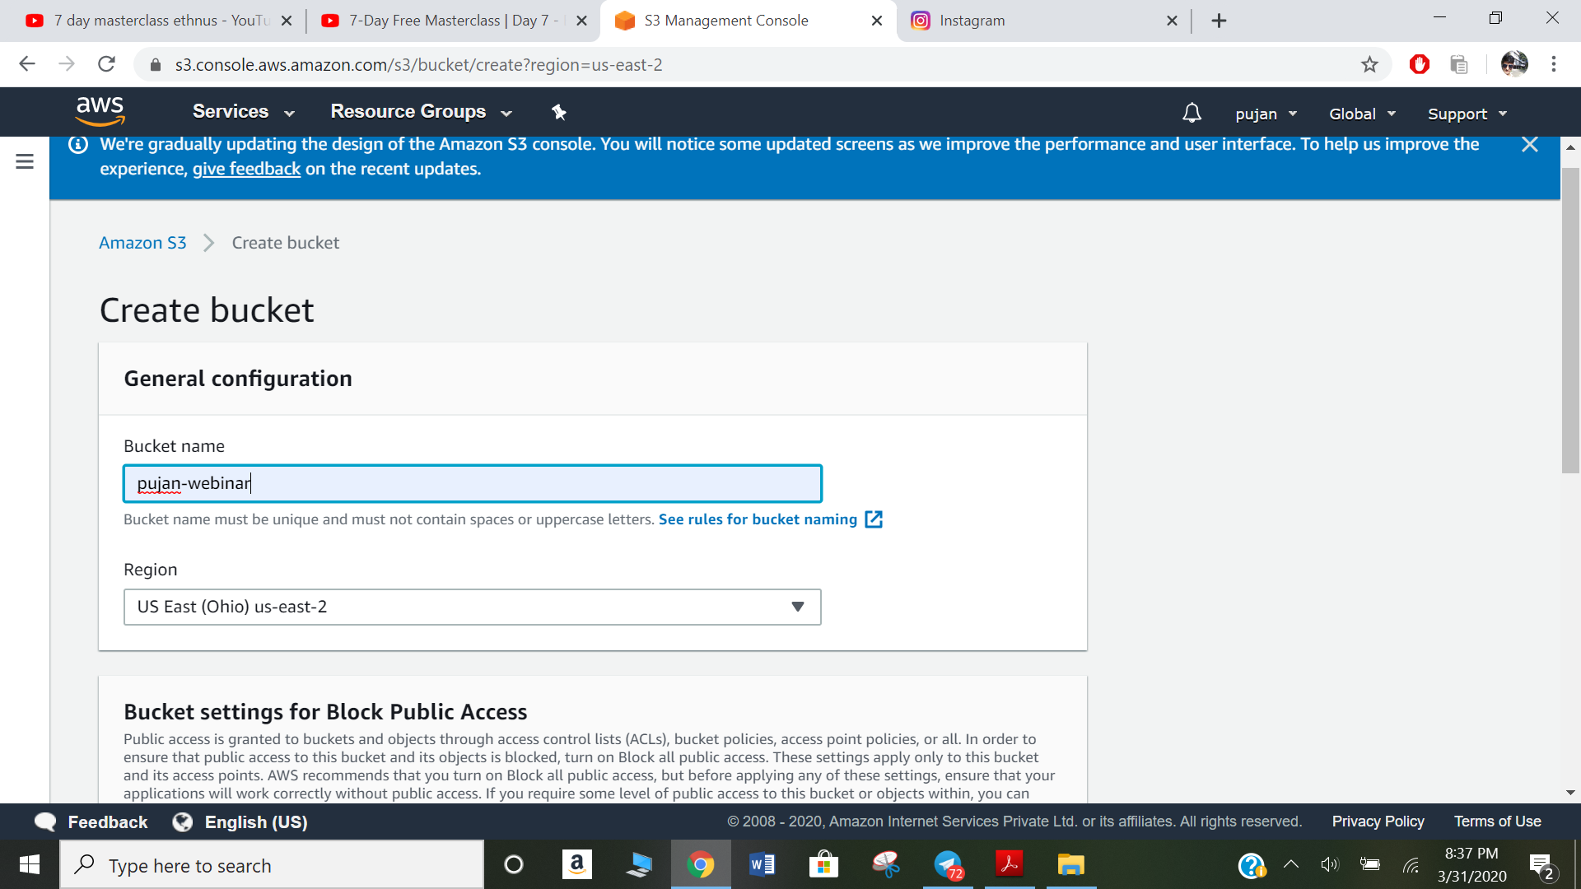

1. Uploading an Object

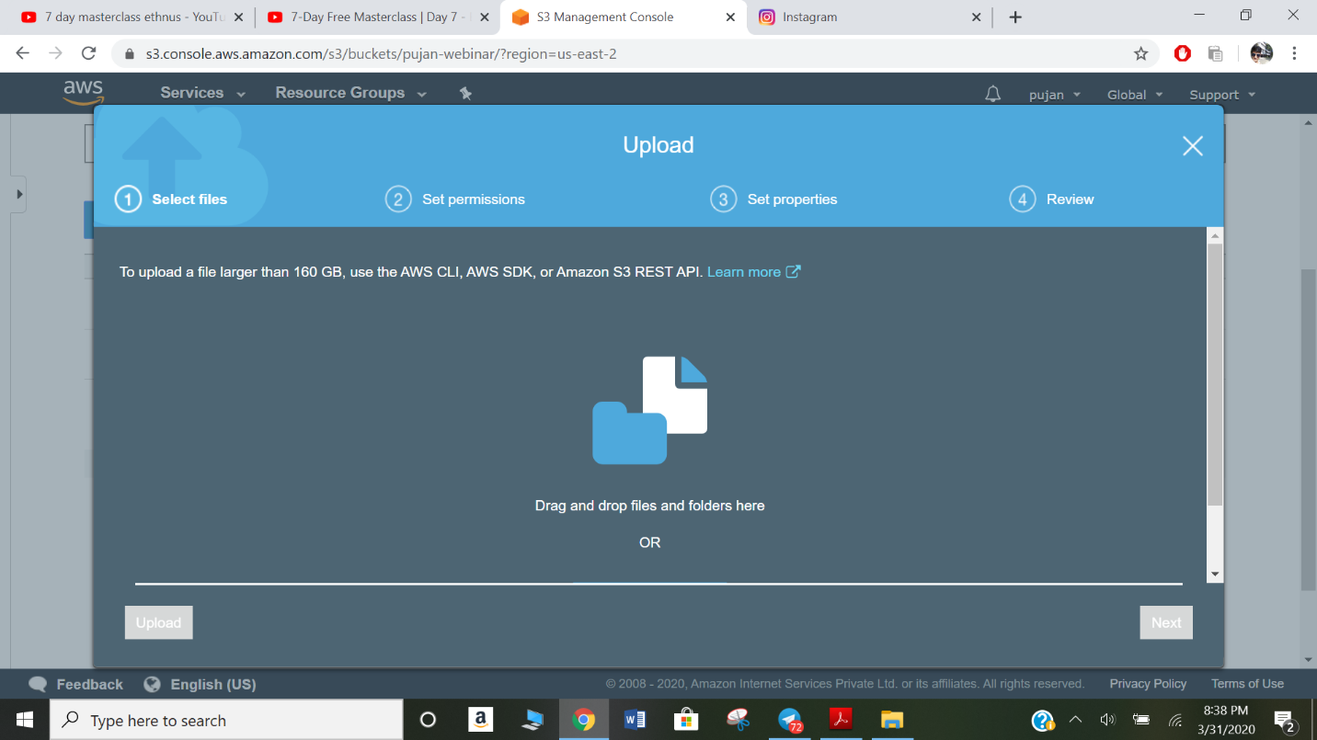

1. Enabling Static Website

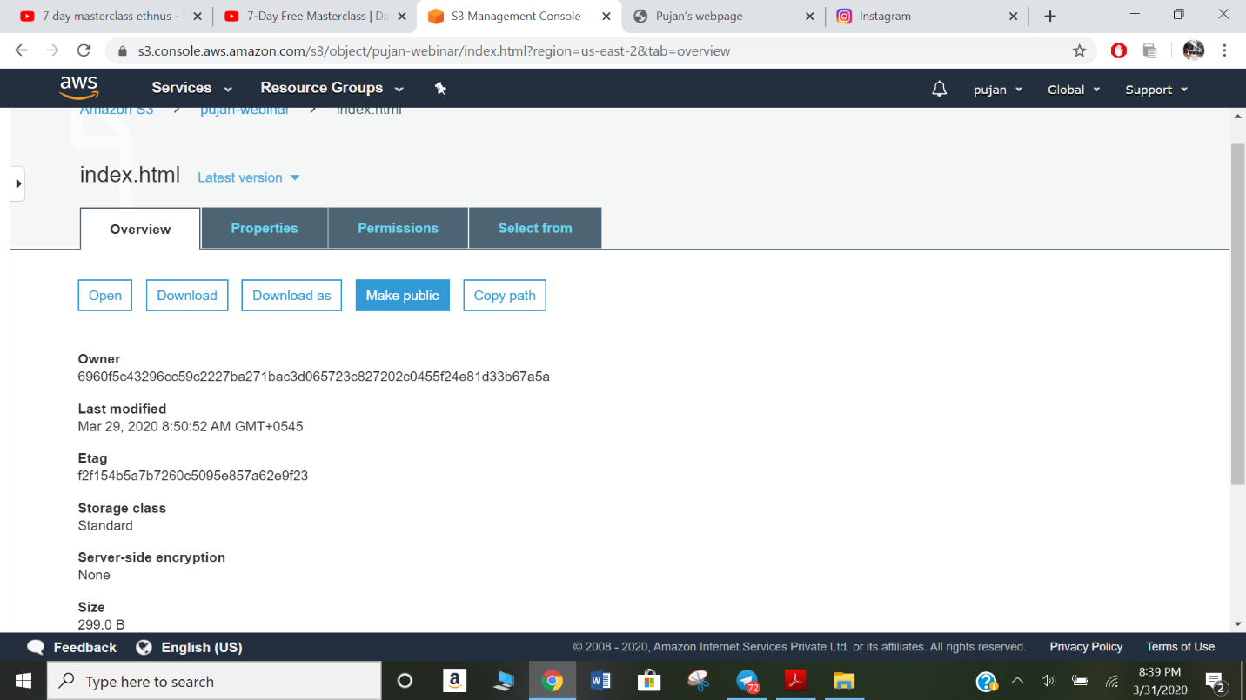

1. Making the Object Public



1. Checking the S3 link on the browser

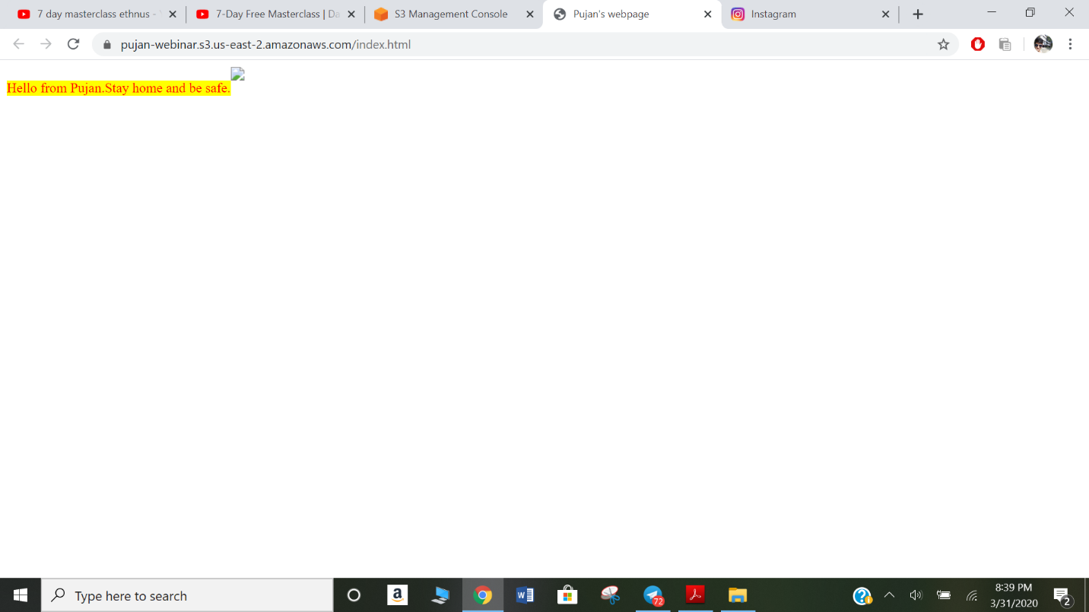

Screenshots needed for Rekognition

1. Face Detect

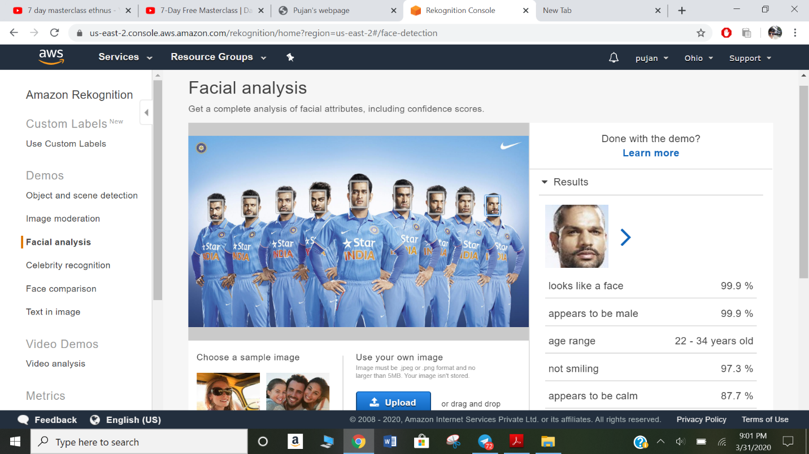

1. Celebrity Recognition

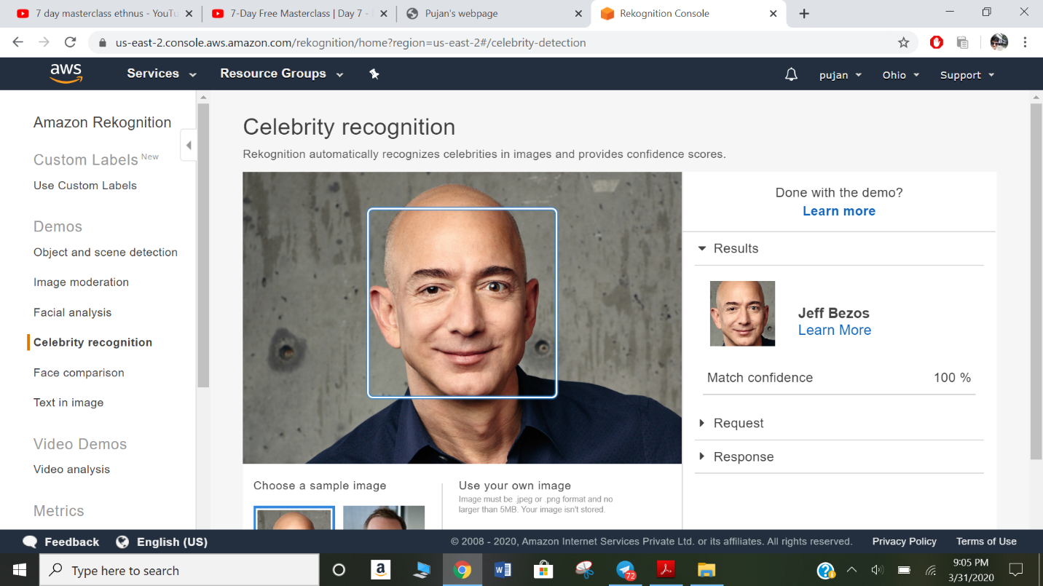

1. Text in Image

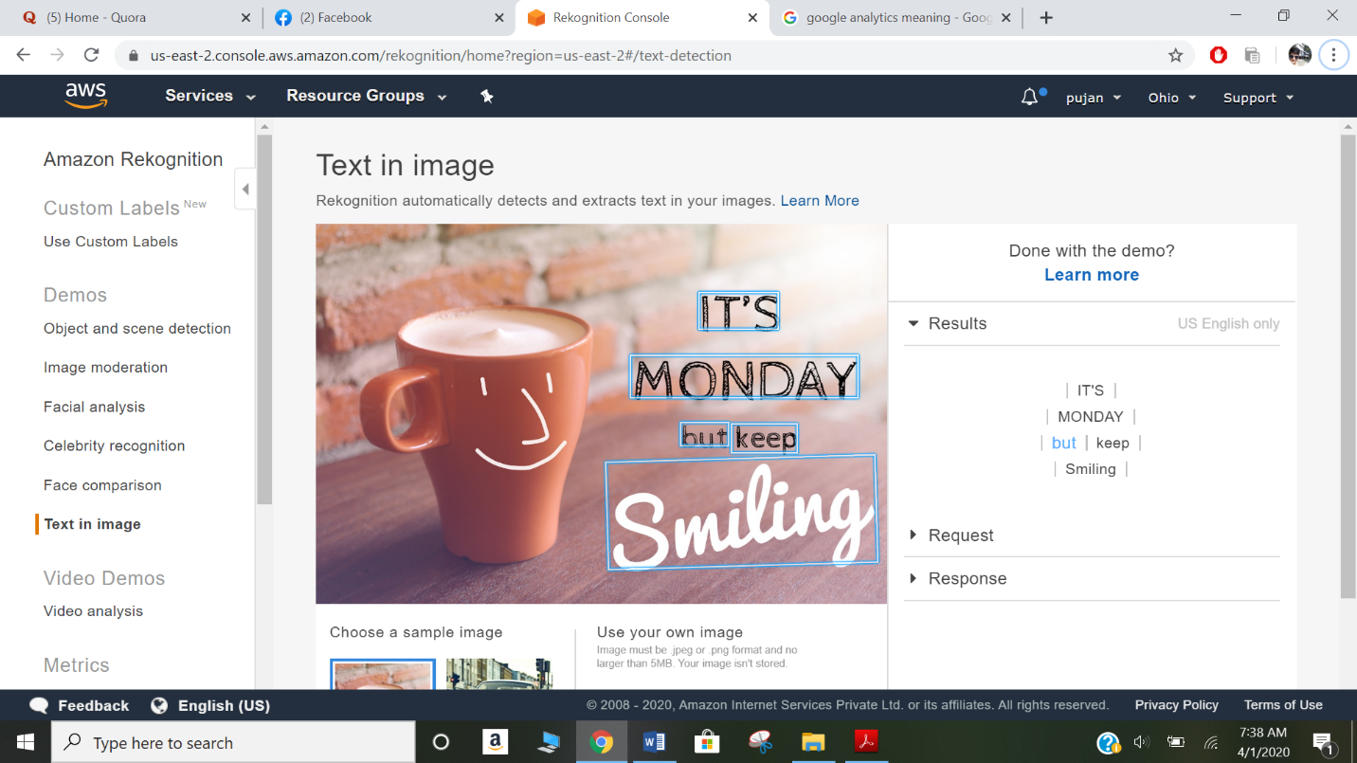

Screenshots needed for EC2 & S3

1. Installing aws-sdk/Installing php

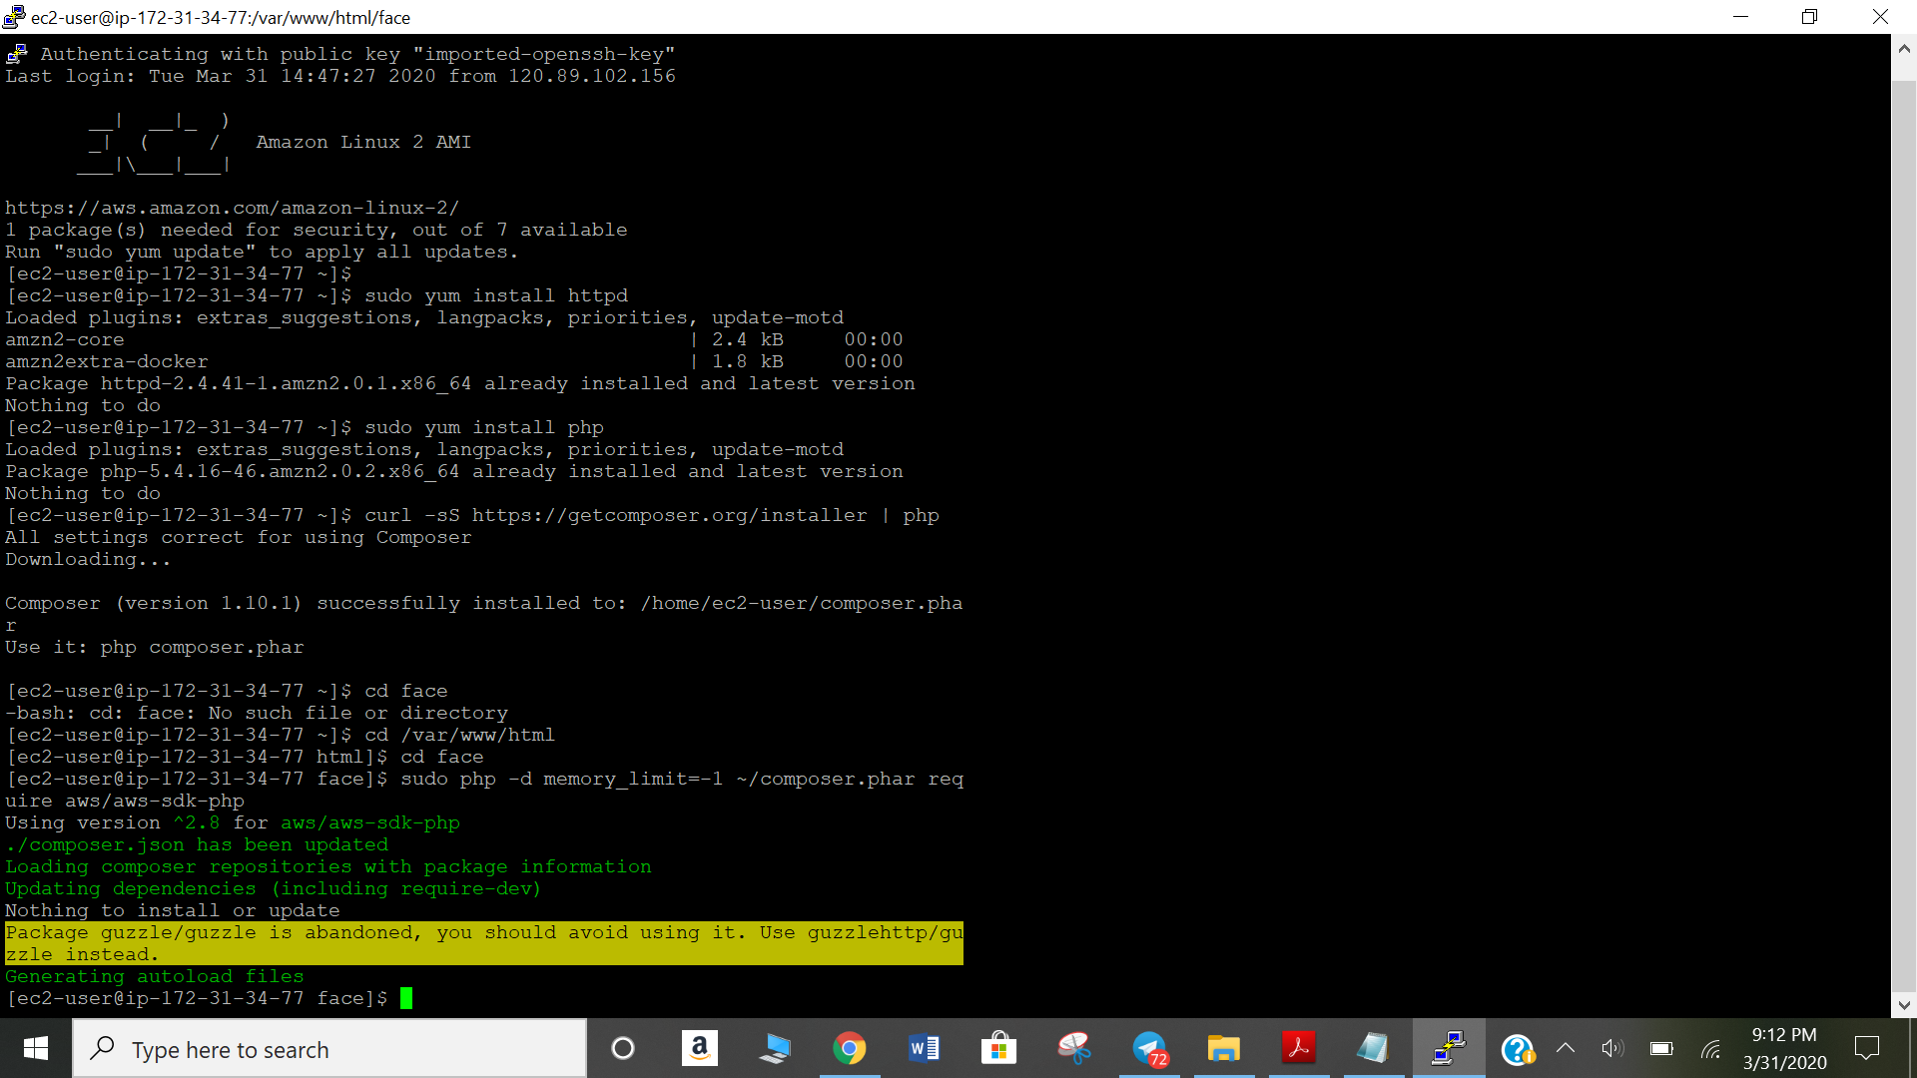

1. index.php file code

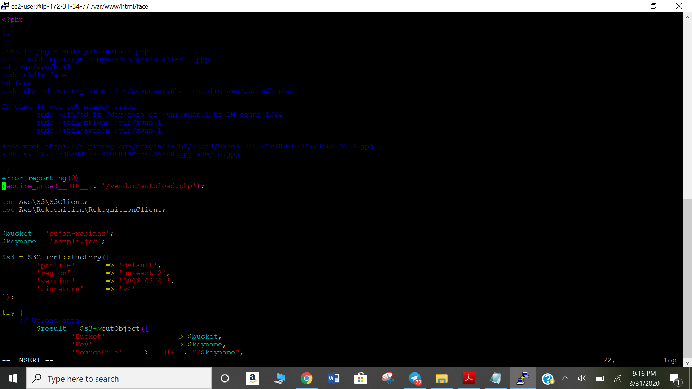

1. Upload success screenshot

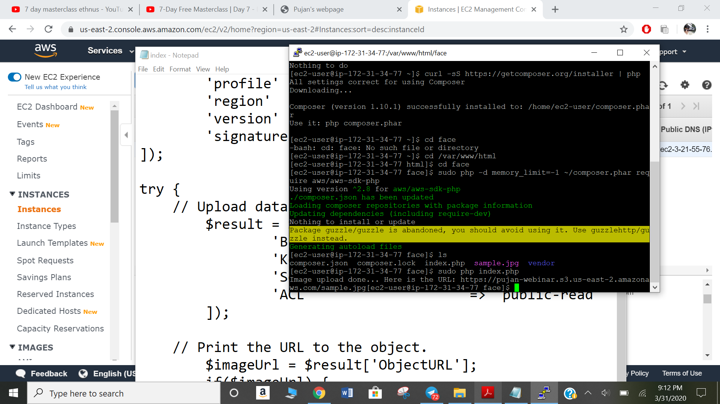

Screenshots needed for EC2 & Rekognition

1. Face Detect success screenshot

